**ELECTRONIC WORKSHOP (ECW-104)**

**SMART DOOR LOCK WITH SECURITY**



**SYNOPSIS**

**ABSTRACT**

In today's world, smart home control system is necessary in daily life. As the technology is emerging a lot it's time for us to be more technical related to home secure security and easy access to the user. This technique basically deals with key less door lock system using smart phone in which SMS, E-mail, Image, anti-burglar will be used and for guest users it will generate b-id. This will allow the guest user key to access the door for a given particular time only. The system also includes motion detectors that will help to determine the user. If an unauthorized person is trying to access the door, then camera will take snaps of user at the door. These snaps will be sent to owner. Furthermore, this approach can be applied and extended to different institutions like banks and offices.

**INTRODUCTION**

Security describes protection of life and property. There are doors to keep people out, Key chains reinforce the mode of security. Doors are being made of metals not just wood anymore. Influential persons in our society have bullet proof doors to ensure a good measure of security of self and family. The security sector is experiencing diversification as it has never seen before. This has brought about the need to review the reliability of already existing systems and look into the possibility of creating better systems that are smarter and more secure. The micro controller based digital lock presented here is an access control system that allows only authorized persons to access a restricted area, this system is the best suitable for corporate offices, automated machine (ATM s) and home security.

1. **OVERVIEW**

##### Existing System

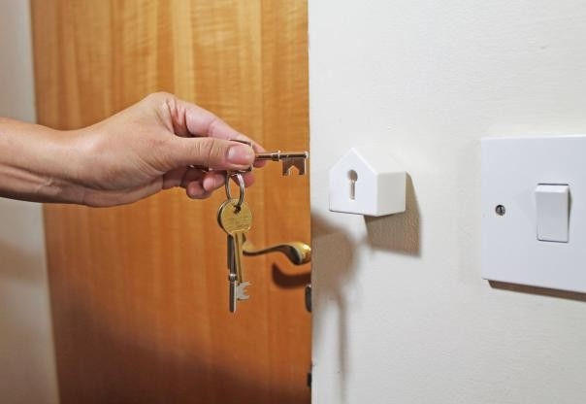

Fig:1

The existing system largely consists of physical lock and keys. The problem with existing system is that it can cause security issues with the case of burglaries . The burglar can grapple with the vault key and study it which can cause considerable damage to the property and valuable materials in the safe. Also, physical locks can be opened by lock picks.

## WORKING PROCEDURE OF THE PROJECT

The operation of this project is summarized as follows;

* 1. A call is placed to the phone that is connected to the system, this call is like any normal call to a friend, colleague etc. the call made is set to be automatically answered at the other (i.e. door) end, the caller immediately presses six digits numbers (password).
  2. The signal qualities of the tones are first increased by passing it into a step up transformer, the output of which goes to the DTMF decoder.
  3. In the DTMF decoder the tones are received and decoded into a binary code equivalent, the output of the decoder is sent to the micro controller.
  4. The micro controller’s internal programming processes the output from the DTMF decoder. Here, these decoded signals are identified as the key s pressed on the phone keypad. The micro controller output these informations into three unit;
  5. Liquid crystal display unit, to show the user the digit pressed.
  6. The ULN2003 driver. This converts the logic level

from the micro controller’s TTL to the signal that controls the switching sequence of the relay.

* 1. On entry of the six digit code the “#” button of the

keypad is pressed as confirmation of the code. If the code entered is correct, (if the user mistakenly typed wrong digit, this can be delete by pressing “0” key to backspace) data is sent to the micro controller to activate door opening sequence; this sequence includes the display of an “Access Granted” text on the LCD screen and the output of a signal to the transistor driving the relay. This signal causes the relay contacts to switch and completes the motor circuit thereby causing the door to open.

* 1. The door closes automatically after precisely 8

seconds, but user can close the door by pressing the “#” key on the keypad. The micro controller is programmed to recognized this character and bring about the switching action of another relay which closes the door.

#### PURPOSE OF THE PROJECT:

* + - The goal of the project is to develop a unique system through **MOBILE TECHNOLOGY** which can control various units of the houses, industries, and also provides a security system.
    - The various appliances can be utilized by managing them remotely by using GSM technology, which enables the user to **remotely control** the operations of the appliances.
    - Just by pressing **keypad of remote telephone** the user can perform ON/OFF operations on the appliances.
    - Unlock the door by using pre-decided

#### password.

* + - Increase the security level to prevent an

**unauthorized unlocking** of the door.

* + - To prevent the opening of the door by unauthorized persons.
    - Flexibility to the user to change or reset the password
    - More secure yet cost-efficient way of door locking-unlocking system.
    - Contains a matrix key pad, door system and a GSM modem for the security dial up interfaced to the micro controller.
    - The keypad interfaced to the controller is used as the password entry.
    - As soon as the user enters the correct password, the door lock opens.

#### THE PROPOSED SYSYTEM

1. **Block diagram**

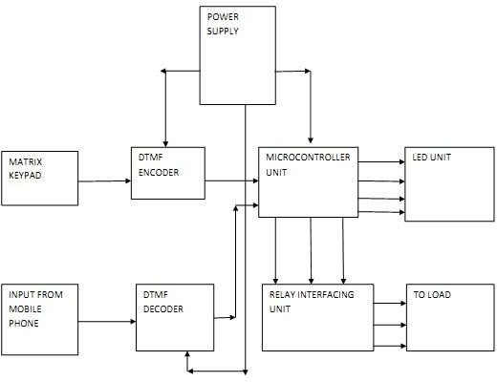The block diagram of proposed system is as shown below

Fig:2

#### Description of Blocks

The major blocks used in the said system are as follows:

* MICROCONTROLLER

The AT89S52 is a low-power, high-performance CMOS 8-bit microcontroller with 8K bytes of in- system programmable Flash memory. The device is manufactured using ‘Atmel’ high-density nonvolatile memory technology and is compatible with the industry-standard 80C51 instruction set and pin out. The on-chip Flash allows the program memory to be reprogrammed in-system or by a conventional nonvolatile memory programmer. By combining a versatile 8-bit CPU with in-system programmable Flash on a monolithic chip, the ‘Atmel’ AT89S52 is a powerful microcontroller which provides a highly- flexible and cost-effective solution to many embedded control applications.

The AT89S52 provides the following standard features: 8K bytes of Flash, 256 bytes of RAM, 32 I/O lines, Watchdog timer, two data pointers, three 16-bit timer/counters, a six-vector two-level interrupt

architecture, a full duplex serial port, on-chip oscillator and clock circuitry. In addition, the AT89S52 is designed with static logic for operation down to zero frequency and supports two software selectable power saving modes.

The Idle Mode stops the CPU while allowing the RAM, timer/counters, serial port, and Interrupt system to continue functioning. The Power-down mode saves the RAM contents but freezes the oscillator, disabling all other chip functions until the next interrupt or hardware reset.

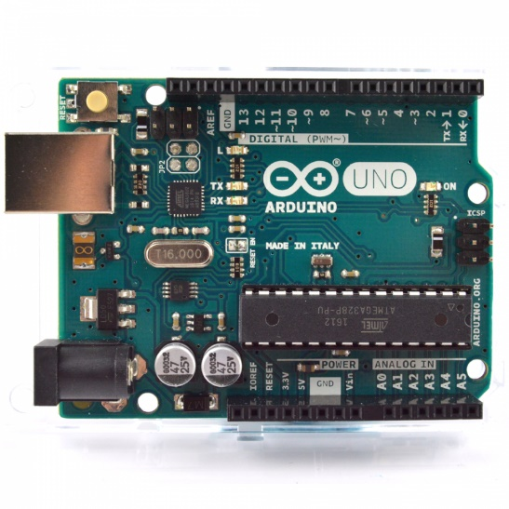

Fig:3

PIN DIAGRAM

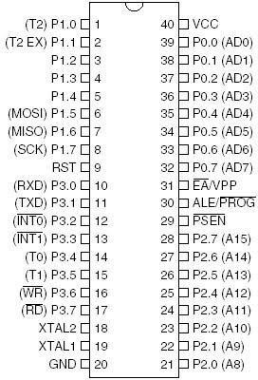

Fig:4

#### POWER SUPPLY

The input to the circuit is applied from the regulated power supply. The ac input i.e., 230V from the mains supply is step down by the transformer to 12V and is fed to a rectifier. The output obtained from the rectifier is a pulsating dc voltage. So in order to get a pure dc voltage, the output voltage from the rectifier is fed to a filter to remove any ac components present even after rectification. Now, this voltage is given to a voltage regulator to obtain a pure constant dc voltage.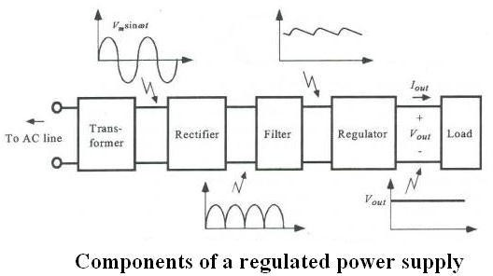

Fig:5

#### LCD

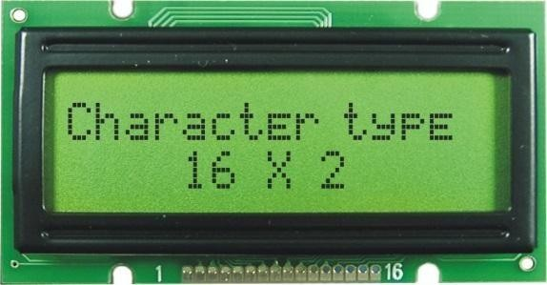The LCD used here is 16x2 alphanumeric Liquid Crystal Display (LCD) which means it can display alphabets along with numbers on

Fig:6

2 lines each containing 16 characters. It is used to display the password entered and the status of the password. It can be used to display the various options and all the readings that have been stored in the EEPROM.

#### Mobile handset

It consists of an android mobile handset having Bluetooth. The mobile device also needs to have the required application installed. This android mobile is used to send command using the GSM technology.

#### GSM MODEM

GSM/GPRS MODEM is a class of wireless MODEM devices that are designed for communication of a computer with the GSM and GPRS network. It requires a SIM (Subscriber Identity Module) card just like mobile phones to activate communication with the network. Also, they have IMEI (International Mobile Equipment Identity) number similar to mobile phones for their identification. A GSM/GPRS MODEM can perform the following operations:

* 1. Receive, send or delete SMS messages in a SIM.
  2. Read, add, search phone book entries of the SIM.
  3. Make, Receive, or reject a voice call.

The MODEM needs AT commands, for interacting with processor or controller, which are communicated through serial communication. These commands are sent by the controller/processor. The MODEM sends back a result after it receives a command. Different AT commands supported by the MODEM can be sent b y the processor/controller/computer to interact with the GSM and GPRS cellular network.

#### Relay

Relay acts as a switch which is used to control the 230 volt AC supply. This relay will be turned off if there is no person inside the room. This relay can be used to turn off the electrical appliances like fan, tubes etc.

## SOFTWARE AND PROGRAMMING LANGUAGES

The following software were used for development of the proposed system

* EAGLE software for PCB designing
* KEIL compiler

## vi . STEPS IN PROJECT DEVELOPMENT

The following steps were taken during the development of the proposed system:

* Defining the problem.
* Research about existing systems.
* Developing the block diagram.
* Designing and testing the circuits.
* Developing the PCB layout using EAGLE software.
* Etching the PCB.
* Soldering all components on the PCB board.
* Testing and troubleshooting the PCB board.
* Software development.
* Testing and debugging the code.
* Burning the code on the IC.
* Testing the entire system.
* Preparing a working model.
* Documentation.

## APPLICATIONS

The proposed system as a wide range of applications, some of them are as follows:

* Home security
* Can be used in offices
* Can be used to secure industrial plants against intruders
* Can be installed at any place where remote access is required.

## CONCLUSION

The work was successful. It is evidence that the use of mobile phones with the right circuitry can be used to operate a security system, since the mobile phone in today’s world; it is an access device a lot easier and affordable to obtain as opposed to specially fabricated keys and smart-cards. The ability of the system to accesses a secure place (Home, office, ATM etc.) remotely almost anywhere in the world is a plus since technology has made the world a global village.

#### ENHANCEMENTS

My area of interest is control of door lock using mobile phones via Bluetooth. My future study of this project includes implementing more complex security mechanisms such as fingerprint detection and face detection for a more robust security mechanism as well as extending support to windows and ‘iOS’ devices so as to cover a wider range of devices.

## REFERENCES

1.Internet Sources

1. [www.google.com](http://www.google.com)
2. www.wikipedia.org